ExpressCluster Product Overview

NEC’s award-winning ExpressCluster is an essential high-availability clustering solution providing fast recovery and high reliability to maximize business critical application and data availability
Introduction

NEC’s ExpressCluster product is a synchronous clustering software solution integrated with both the application and database server. Designed to ensure high availability of business critical application and data ExpressCluster is extremely efficient resulting in guaranteed data integrity management with the ability to cluster systems across geographical distances.

The result is dramatically fast application recovery in minutes. NEC's solution is deployed and run externally to existing applications, requiring only minor system configurations to take advantage of its benefits. The product includes an easy to use administrative console for configuration, monitoring, and reporting.

Cluster technology

An essential function of any mission-critical business system is that it delivers the required performance at all times to handle vast amounts of data. A mission-critical business system must also ensure reliability, since its failure will bring the company’s entire business operation to a halt and result in considerable losses.

History of Clustering Technology

Dual systems and duplex systems, which adopted a redundancy configuration as a means of enhancing reliability, had for some time been available for general purpose machines. However, these systems required special hardware and software and were therefore expensive to build. That expense was something the procuring business had to accept as a cost of reliability.

When client/server systems became the mainstream in the 1990s, UNIX software emerged that provided an affordable, redundant system consisting of inexpensive servers connected by a LAN and SCSIs. Subsequently, what emerged and gained popularity was the so-called “clustering” technology, which ensured reliability via redundancy while achieving high performance based on the parallel processing of multiple SMP (Symmetric Multi Processing) servers. The number of parallel-processing SMP servers operating in clusters is likely to increase further.

Given its relatively brief history as an operating system, Windows is now entering the enterprise server market Japan, offering more than just PC/information server functions. Clustering technology should become an essential driver that will push the application of Windows into the realm of mission-critical business systems.

The word cluster means “a bunch of things.” In the technical world, a cluster refers to a group of servers and a technology that allows those servers to operate as a single unit. Clustering improves server reliability through redundancy while it also improves server performance by distributing loads and processing them in parallel.
Shortening the system MTTR (Mean Time to Recover) through a redundant configuration will improve “availability,” while enhancing performance by adding cluster nodes will improve “scalability.”

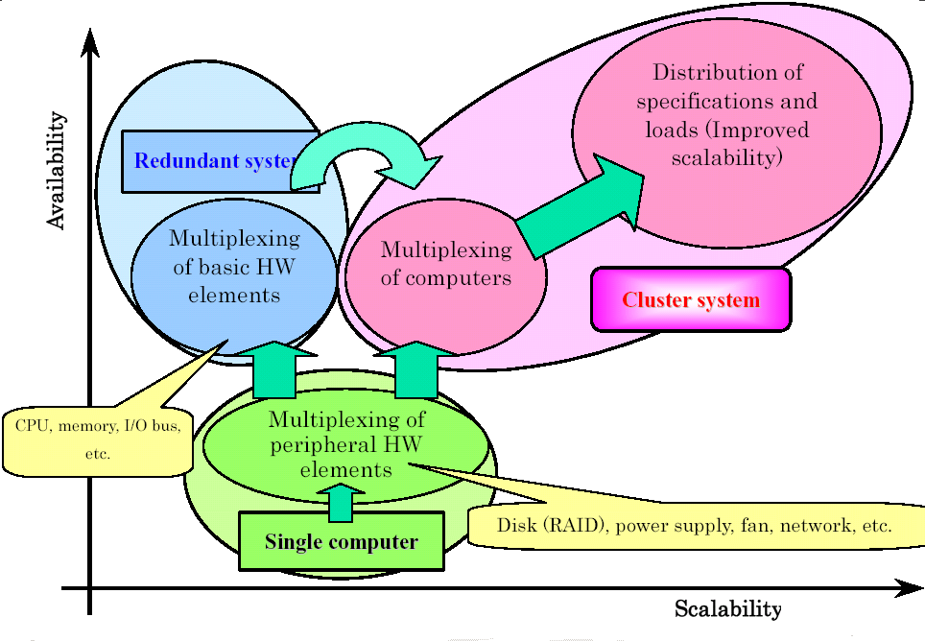

Cluster Models

Cluster models are classified as follows, based on how disk access is controlled.

The “Shared Everything” Model
This model allows multiple nodes to access a single disk simultaneously.
Since data stored on the disk can be accessed simultaneously from multiple nodes, the same business process can be performed at each added node even when more nodes are added.
Note that simultaneous access from multiple nodes means that exclusive control is required in the event of write contention. A Distributed Lock Manager (DLM) performs this exclusive control.

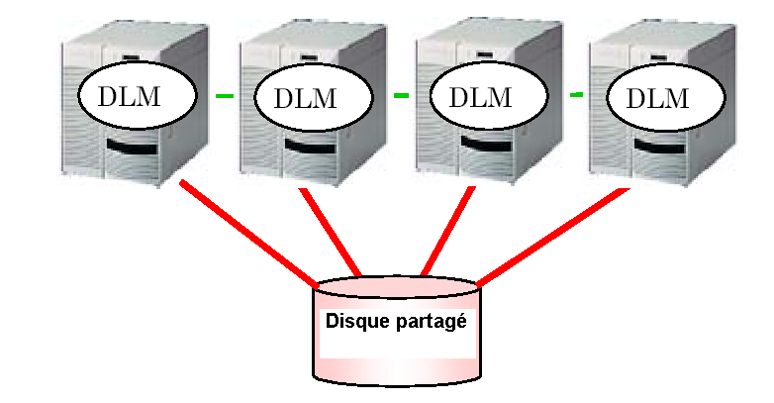

The “Shared Nothing” Model

This model allows each node to access only a given disk. Parallel processing requires that all nodes have appropriate data to be processed. However, as long as the data is distributed properly, no exclusive control will be required among the various nodes when data is written to the disk, even if the number of nodes is increased. As a result, incrementally better linear performance can be achieved.
However, this model requires the identification of whichever node has given processing data, but without causing the application to recognize such information.
Accordingly, middleware such as a transaction monitor must be used to achieve proper distribution corresponding to data allocation.
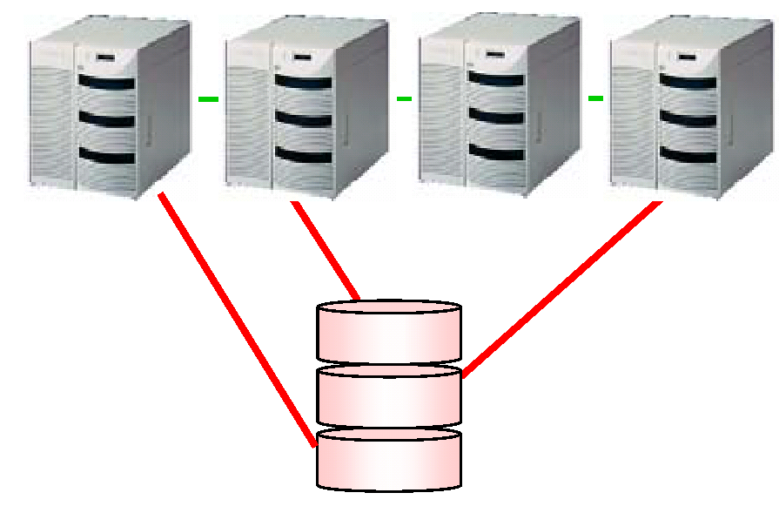

Current Status of Clustering Solutions

The file systems supported by Windows have no DLM function. Therefore, when multiple nodes simultaneously access a file in a partition formatted by NTFS or FAT, Windows cannot perform exclusive control on the filesystem level and the data will be damaged as a result. A Microsoft Cluster Server (MSCS) operates in these file systems, so access from multiple servers is not permitted.
An Oracle Real Application Cluster and Oracle Parallel Server has an independent DLM function. This uses a raw partition (unformatted partition) as a database file and performs physical I/O processing without using a file system, thereby achieving a unique form of exclusive control that is not dependent on the file systems supported by the OS, cache memory, etc.

Cluster Standby Modes

Almost all Windows clustering software products available today improve availability. Generally, redundant servers use one of the following three standby modes:

Cold Standby Mode

The standby node stands by without its OS running. When a failure in the active server is detected while the standby server is still not powered up or immediately before its OS is booted up, the OS of the standby server will boot up.
Thus the standby server will start, becoming the active server. Due to the above process, in this standby mode it takes longer to switch servers when the active server fails.

Warm Standby Mode

In this mode the OS of each node in the cluster is running, and the clustering software controlled by the OS monitors the other nodes. Monitoring uses an inter-node communication protocol called a “heartbeat,” and a server failure is detected by an interruption of the heartbeat.
When a failure in a server is detected, the standby server will take over the disk data and IP address and start the necessary applications.

Hot Standby Mode

This mode corresponds to a dual system/duplex system traditionally achieved with general-purpose machines. Not only the OS but also the middleware and even applications are running in this standby mode. The standby system is operating in the same manner as the active system.

This mode requires software that recognizes clusters, but in the event of a failure servers can be switched quickly.
A majority of the NT clustering software products available today employ the warm standby mode. Although the server switching time is longer than in the hot standby mode, in a warm standby system there is no need to have upper middleware and applications recognize clusters.

Overview of ExpressCluster

ExpressCluster is a high-availability clustering product that provides a warm standby cluster of the “shared nothing” model to data availability in event of primary site outage. ExpressCluster achieves an economical Windows cluster system based on NEC’s innovative technology and deep understanding of the internals workings of Windows. The first version of ExpressCluster was released in October 1996 as an ESM Series product, more than a year prior to the release of the Microsoft Cluster Server. Version 7.0, released in June 2003, is a full-scale cluster system that supports Windows 2000/2003 and Linux.

Data Availability Features

The key to minimize data loss in event of system outages and destruction is timely replication. ExpressCluster provides synchronous mirroring capability that ensures replication of any data successfully written to the primary system disk thus guaranteeing minimum data loss.

Application Availability Feature

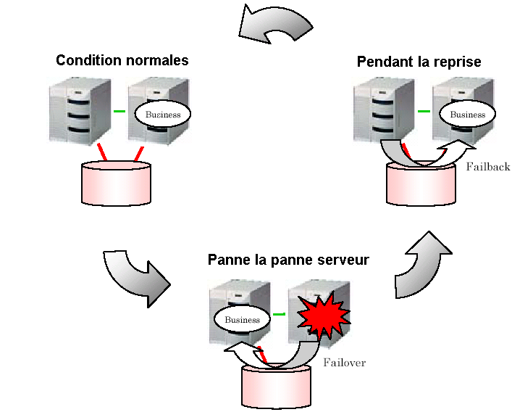

The clustered servers monitor each another, and when the active server fails the standby node will take over the business process from the failed server and continue the task. This takeover action is called “failover.” It is possible to assign different processes to two servers and designate each server as the standby node for its counterpart. Also, in a four-node system one node can be designated as the standby server for the remaining three nodes.

The term “failback” refers to the return of the failed-over process to the original server once the failure has been restored. Failback fully restores the original condition, but if the business process is performed on only one server at a time, the server thus recovered can immediately become the new standby server without a failback process ever having to take place.

Server Monitoring

The servers are monitored through a communication protocol called a “heartbeat” via a LAN linking the servers (called an “interconnect”). The server interconnect adopts a redundant configuration consisting of a LAN, to which the client connects (called “PublicLAN”), and a dedicated LAN linking the servers. Another interconnect can be added to allow server monitoring to continue even after one interconnect has been severed.

Failover

When a server failure is detected, the resources (disk, IP address, etc.) in the failed server will be transferred to another server and the required applications and services will be started in the alternate server.

Transferable Resources
Disk | Mirrored  disk | Can be transferred between  servers in units of logical disks
Client  connection | TCP/IP | An IP address can be transferred between servers.
Client  connection | NetBIOS | A computer name can be transferred between servers.
Applications,  services | Can be transferred between servers based on  the start/stop scripts (batch file) controlled by  ExpressCluster.
Failback

After failover has occurred the failed server can be removed from the cluster group for repair without affecting normal cluster operations.
Once the failed server has been repaired or replaced it can be added back to cluster without interrupting normal operation of the active server.

ExpressCluster features

The following key features are available with ExpressCluster:

- Integrated application failover and data mirroring solution

It is easy to deploy a high-availability solution for local or remote application failover and real-time data mirroring. No need for costly integration of multiple components to achieve full highavailability solution.

- Minutes for Disaster Recovery

Primary system/site failure is quickly detected to trigger automatic failover to the backup system. Access to business critical application and data is recovered within minutes instead of hours or days with traditional disaster recovery solutions and procedures.

- Guaranteed transaction data integrity

Synchronous data mirroring technology guarantees data integrity between production local database and remote one.

- Greater geographical distance support

Support up to 200 miles with dedicated T1 line interconnect, or Coast-to-Coast clustering system deployment for selected solutions, such as Lenel OnGuard.

- Manageability, Reliability & Robustness

Easy installation and event/log tracking, and higher granularity of system failure detections.

- 99.999% system availability

With NEC’s Fault Tolerant server, ExpressCluster solution provides 99.999% availability and minimizes chances of remote failover operations that require service interruptions, failover and fail back operational risks.

Conclusion

NEC’s ExpressCluster offers advanced high availability infrastructure with very low TCO achieved through its integrated application and data recovery ability — all at a competitive price. ExpressCluster’s proven synchronous clustering technology ensures transactional data integrity guaranteeing no lost data or dropped transactions, as compared to asynchronous solutions that are inherently more loss-prone, including when geographical distance is required for the clustered system. When combined with
NEC’s Fault Tolerant servers, only NEC can deliver the ultimate high availability solution for protection against failure of both hardware and software, without increasing
IT complexity and system integration costs.

NEC's intelligent synchronization approach to both application and database cluster management offer customers radical system availability benefits including disaster recovery. With ease of deployment and management as key design elements, NEC delivers a significantly reduced total cost of ownership when compared to alternative solutions.

